Epic Name

Users  - Primary  - Community Admin  - Secondary  - … | Phase 1
Intended Outcome
- Community page creator who is a real member of its own community can also join as member
- …
Links
- …
- …
- …
- …
- …

Introduction
Communities usually choose organizers from their own members although some have special cases where external people are chosen to manage communities. Kolavo wants to facilitate internal members becoming organizers by providing community page creators an access to also join as members. This way each community in Kolavo will reflect the real community condition where community organizers are also counted as community members.

Product Requirement
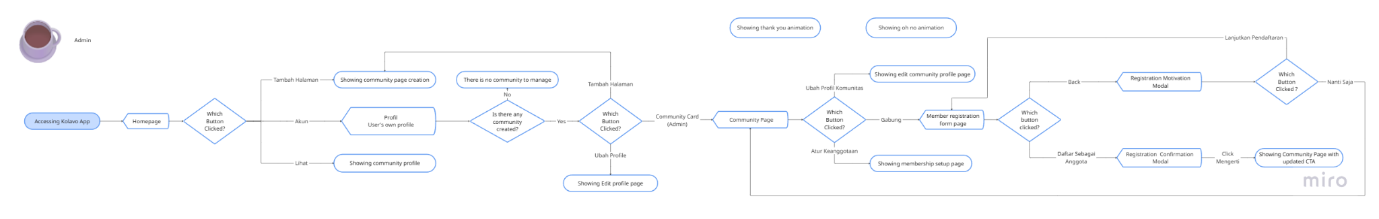
Flow of admin joining as member and managing its own application

No | User story | Scope | Acceptance Criteria
1 | As a community page creator who is also its member for real, I would like to have access to join my own community, so I can send my application. | Join button | - Join button also shows in admin community profile  - Its flow is the same as the member joining flow where it only shows and is active when membership has been set up.
2 | As a community page creator who has applied as a member, I would like to accept my application, so my membership is also counted. | Approval process | - The approval process for admin members is the same as the approval process for members.

Design Requirement

Join Button
Design Intent | To give community page creators access to join their own community.
Content / Copy | - Active state: Gabung  - Pending state: Pendaftaran Sedang Diproses  - Accepted member state: no join button is shown.  - Rejected member state: Pendaftaran Belum Diterima  - Helper text: 🙏 Saat ini kamu belum bisa mengajukan ulang pendaftaran.
Visual Requirement
Interaction Behavior | - If registration is active and admin has not applied, clicking the button opens the membership registration form.  - If the visitor has already applied and the application is pending, the button is not clickable and only communicates the pending status.  - If the visitor is already an accepted member, the button is not displayed.  - If the application is rejected, showing the helper text
Acceptance Criteria

Engineering Requirement

Questions

